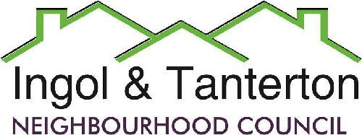
Gill Flynn - Clerk and RFO
Email: clerk@ingoltantertonnc.org.uk

Agenda

All Neighbourhood Councillors are hereby summoned to the meeting of
Ingol and Tanterton Neighbourhood Council on Wednesday 1st April 2026 at 7.15pm
at Tanterton Village Centre.

1.To receive apologies.

2.To receive declarations of interest.

3.To approve the minutes of the meeting held on Wednesday 4th March 2026.

4.Public participation.

5.To consider planning applications, reports and matters.

6.Finance.
Expenditure
BACS | MB Landscaping | Lengthsman basic minus hours 10 Jan and Feb | £444.00
BACS | Gill Flynn – clerk | Monthly expenses | £29.78
DD | British Gas | Cottam Gate electrics | £34.92
DD | EasyWebsites | Domain, hosting and emails | £56.76
BACS | HMRC | PAYE / NI/ Employment contributions | £276.03
BACS | Nurture | Monthly grass cutting schedule | £509.20
BACS | Mcafee | Antivirus / reimbursement G Flynn | £49.99
BACS | Preston City Council | Greenspace contribution 2 years | £18,900.00
Bank reconciliation
Total income £262,596.74
Total expenditure £307,979.07
Bank accounts
Current £15,386.19
Instant access £360,757.07
CCLA £36,079.95
Total £412,223.21(of which CIL reserves £180,979.41)

7.To consider the lengthsman’s update and schedule of works.

8.To consider the proposal for a Tanterton Hub of Excellence.

9.To consider the update from the Area Enhancement Committee.
- Tanterton Village Shops
- New noticeboard for Ingol West Ward.

10. To consider the update on the organisation for the Scarecrow competition and to agree a budget.

11.To consider the grant increase application for 2026/2027 from Intact.

12.To consider the purchase of a new litter bin for Ingol Dip.

13.To consider and adopt the reviewed budget 2026/2027.

14.Reports and correspondence (information only).

15.Date and time of next meetings.

Press and public are welcome to attend.

